Cloning Ubuntu inside VMware ESXi

# Step1

After logging into VMware ESXi click on the storage icon, then click on the Datastore Browser.

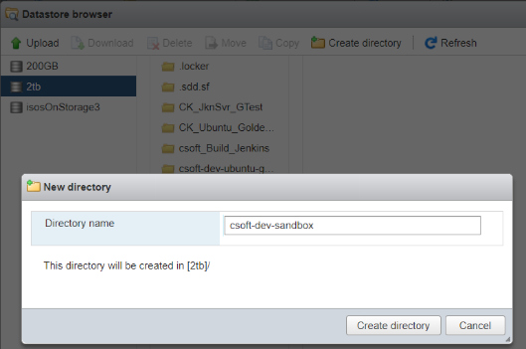

When it opens up create a new directory where you want to store the cloned VM.

# Step 2

After creating the new directory click on the VM which you want to clone. Right click on the VMX and VMDK files, copy both of these files individually. Note : the last snapshot vmdk has to be also copied . This will take you back out to the first part but just click back into the list of directories.

Click on the file where you want to paste the copied file. Here you have to click the copy button for it to work. Each file is copied individually and this part takes a few minutes.

# Step 3

The new VM must be registered. Right click on the VMX file which has been just copied and Register VM.

# Step 4

This will leave two copies of the VM in the dashboard .

Here the cloned VM must be renamed. For the storage to be visible to Ubuntu.

# Step 5

When powering on the cloned machine for the first time a dialog box pops up. Click, I copied it, and Answer

Now your cloned machine is ready to go.